

Project Report:

Intelligent Financial Analytics & Predictive Dashboard
for the Retail Sector

Submitted by –

Gaurav Shripad | 25030241170
Karshna Nagpal | 25030241174
Saugata Dey | 25030241196
Shubh Kesharwani | 25030241200
Jay Shukla | 25030241201
Shraddha Trivedi | 25030241207

A project report submitted to
Dr. Mugdha Kulkarni

Basics of Financial Management
in
MBA IN INFORMATION TECHNOLOGY AND BUSINESS MANAGEMENT
Batch: 2025-2027

Division: ITBM- D

26th January 2026

ABSTRACT
In the contemporary volatile economic landscape, the Indian retail sector presents a complex investment environment characterized by fluctuating consumer demand and rapid market shifts. Traditional financial analysis, relying heavily on manual interpretation of static statements, often fails to capture dynamic market sentiments. Investors face a critical "Information Asymmetry" where data is abundant, but actionable predictive insight is scarce.
This project proposes the design and development of a Data-Driven Financial Analytics Dashboard, a decision support system designed to bridge this gap. Unlike static reports, this solution integrates historical financial data (from Prowess) with real-time market behaviour (via Yahoo Finance API). By utilizing an Ensemble Machine Learning Architecture—combining Random Forest, Gradient Boosting, and Ridge Regression—for price forecasting and Automated Ratio Analysis for fundamental health checks, the system provides a holistic "Buy, Sell, or Hold" verdict. The dashboard successfully democratizes high-level financial analysis, offering a transparent, visualized, and predictive tool for strategic investment.

Table Of Contents

Section | Title/Topic | Page No.
 | Abstract
1 | CHAPTER 1: INTRODUCTION
1.1 | Problem Statement
1.2 | Project Objectives
1.3 | Scope and Limitations
2 | CHAPTER 2: THEORETICAL FRAMEWORK & LITERATURE REVIEW
1.1 | Financial Statement Analysis
1.2 | Ensemble Learning in Finance
3 | CHAPTER 3: SYSTEM ARCHITETURE & METHODOLOGY
3.1 | Data Acquisition Layer
3.2 | Computational Layer
3.3 | Visualization Layer
4 | CHAPTER 4: IMPLEMENTATION & ANALYSIS
4.1 | Fundamental Analysis
4.2 | Predictive Modelling
5 | CHAPTER 5: Results and Discussion
5.1 | Dashboard Output
5.2 | Interpretation
6 | CHAPTER 6: CONCLUSION & FUTURE SCOPE
6.1 | Conclusion
6.2 | Limitation
6.3 | Future Scope
 | REFERENCES

Chapter 1: Introduction

1.1 Problem Statement
The retail industry is capital-intensive and highly sensitive to market cycles. Stakeholders, including retail investors and financial analysts, encounter significant challenges:
- Data Overload: The sheer volume of data from Profit & Loss statements and Balance Sheets across multiple years makes manual trend analysis error-prone and slow.
- Lack of Predictive Insight: Standard financial reports describe what happened (historical) but fail to scientifically forecast what will happen (predictive), leaving investors reactive rather than proactive.
- Model Bias: Relying on a single predictive model often leads to overfitting or underperformance in diverse market conditions.

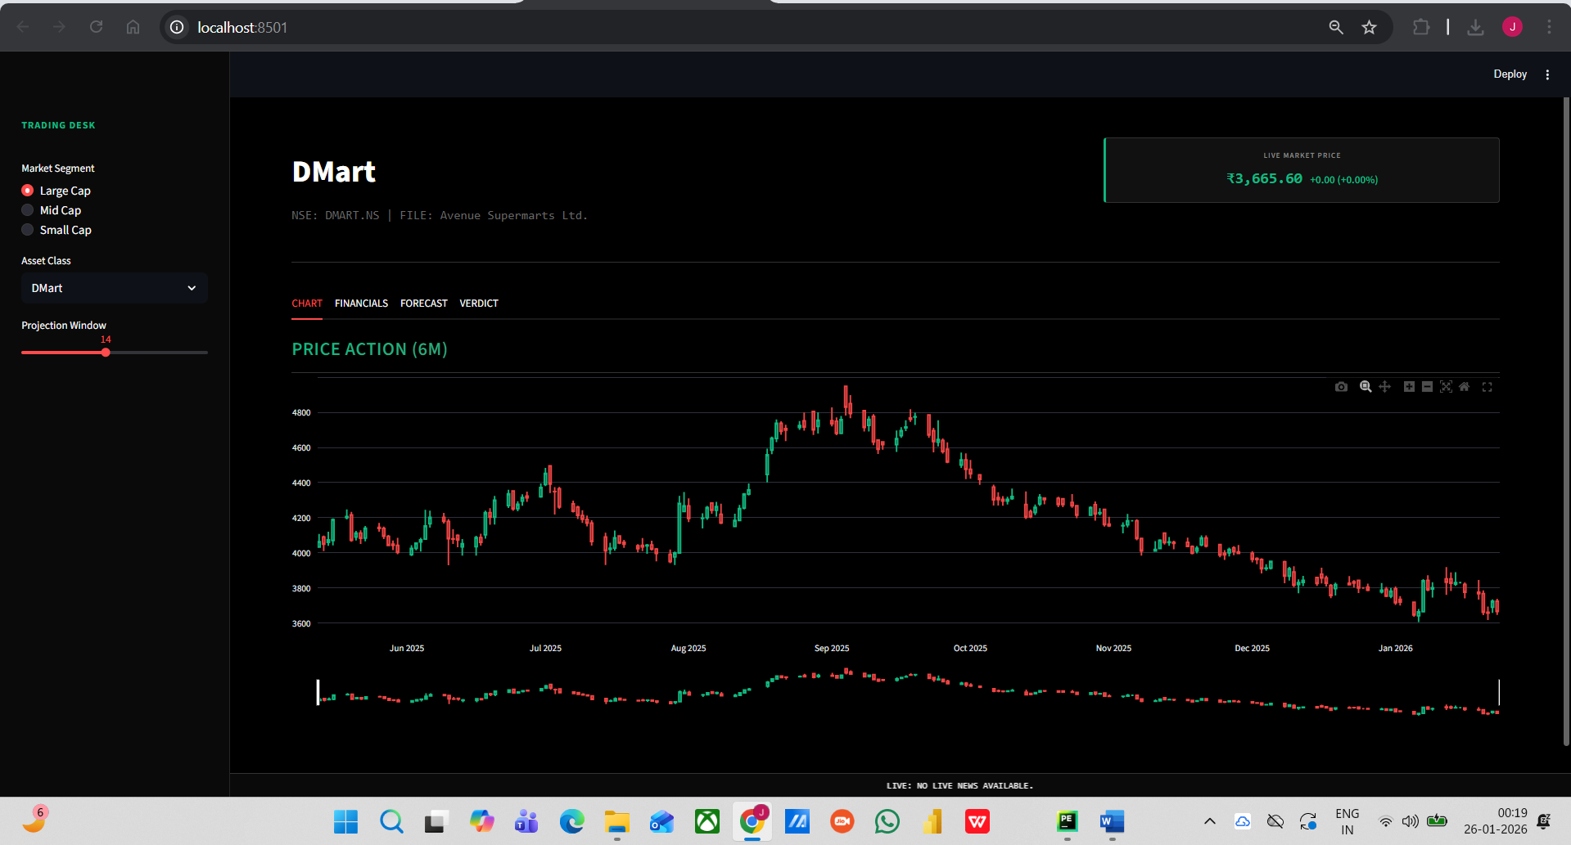

Figure 1.1 : Market Segment- Large Cap

1.2 Objectives
The primary objective is to develop a comprehensive financial dashboard that serves as an intelligent investment advisor. Specific sub-objectives include:
- To automate the extraction and cleaning of financial data (Revenue, Net Profit, Assets, Liabilities) for top retail companies across Large, Mid, and Small-cap segments.
- To implement an Ensemble Learning approach, benchmarking Random Forest, Gradient Boosting, and Ridge Regression to select the best-performing model for stock price forecasting.
- To compute and visualize key efficiency ratios (Current Ratio, Inventory Turnover) to assess operational health.
- To generate an automated investment verdict (Buy/Accumulate/Hold/Sell) based on a weighted scoring of technical and fundamental factors.

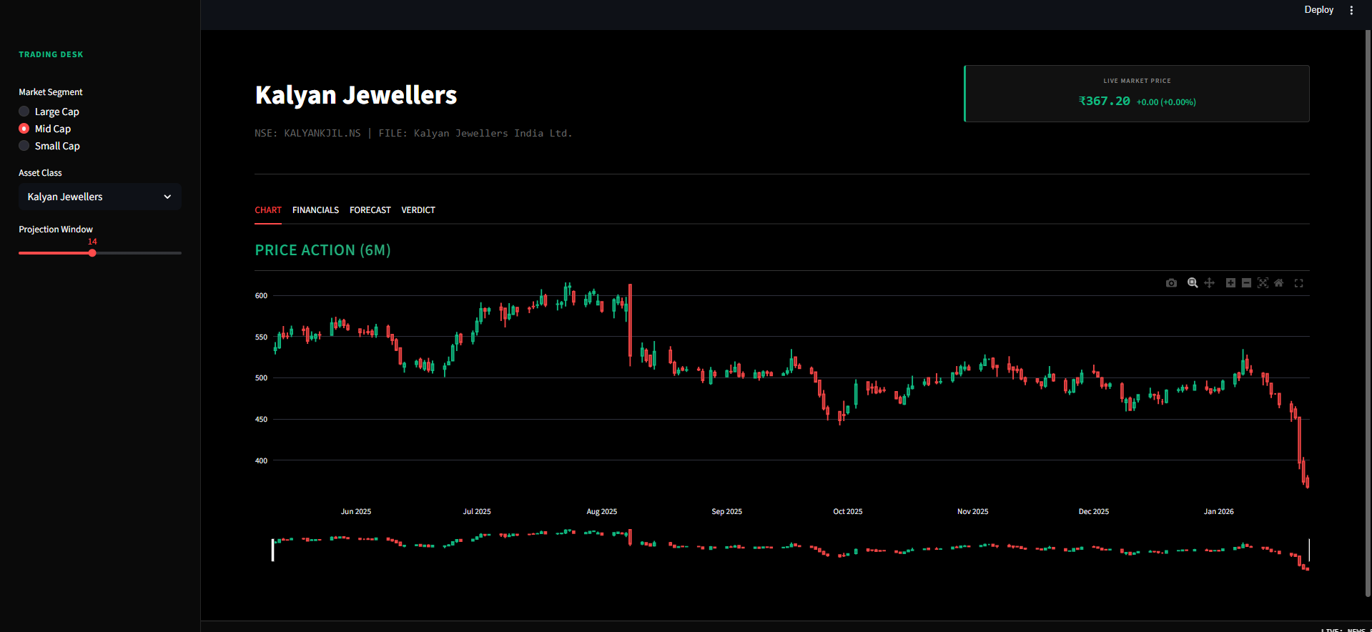

Figure 1.2 : Market Segment- Mid Cap

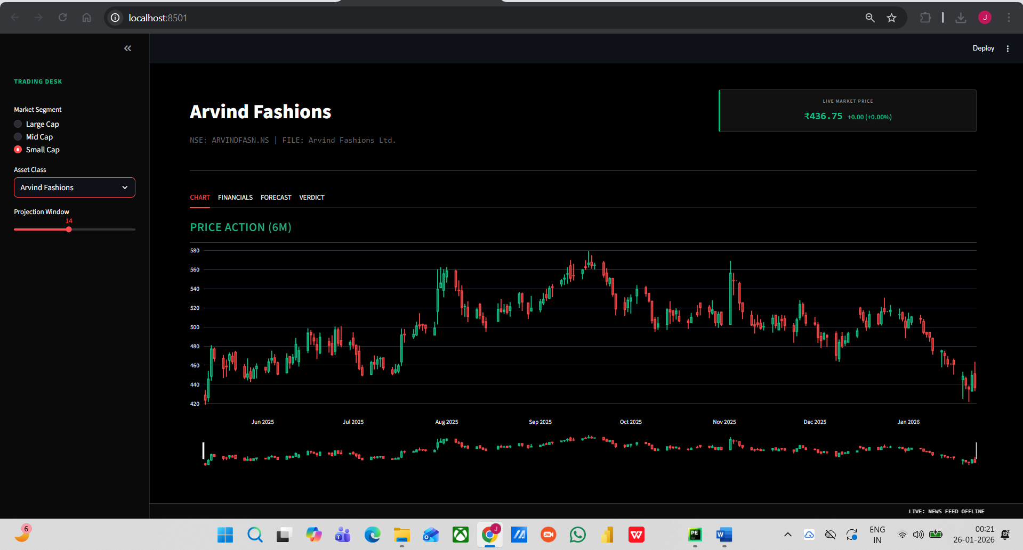

Figure 1.3 : Market Segment- Small Cap

1.3 Scope of the Project
The scope is limited to the Indian Retail Sector, analyzing representative companies such as DMart, Titan, and Arvind Fashion etc. The system utilizes Python for backend computation and Streamlit for the frontend user interface. It focuses on quantitative financial metrics and technical price action.

Chapter 2: Theoretical Framework & Literature Review
2.1 Financial Statement Analysis The project automates standard fundamental analysis techniques, including Common Size Analysis (standardizing financials as percentages) and Trend Analysis (evaluating growth over 5-10 years). These methods are crucial for comparing companies of different sizes (e.g., Reliance Retail vs. Spencer's).
2.2 Ensemble Learning in Finance Recent studies in Computational Finance suggest that no single algorithm is universally superior for stock prediction.
- Random Forest: Excellent for handling non-linear relationships and reducing variance.
- Gradient Boosting (GBM): Focuses on correcting the errors of previous trees, often achieving higher accuracy in structured data.
- Ridge Regression: A linear model with regularization, useful for preventing overfitting when features are highly correlated (multicollinearity). By comparing these, the system ensures robustness against market noise.

Chapter 3: System Architecture & Methodology

The proposed system operates on a Hybrid Data Architecture, merging static archival data with dynamic live feeds.

3.1 Data Acquisition Layer
- Static Data Source: The Prowess Database (CMIE) is used to source audited financial statements (Balance Sheets and P&L) for the past 5-10 years. This ensures the fundamental analysis is grounded in verified corporate filings.
- Dynamic Data Source: The Yahoo Finance API (yfinance) is utilized to fetch real-time stock prices, historical closing prices, and market volume.
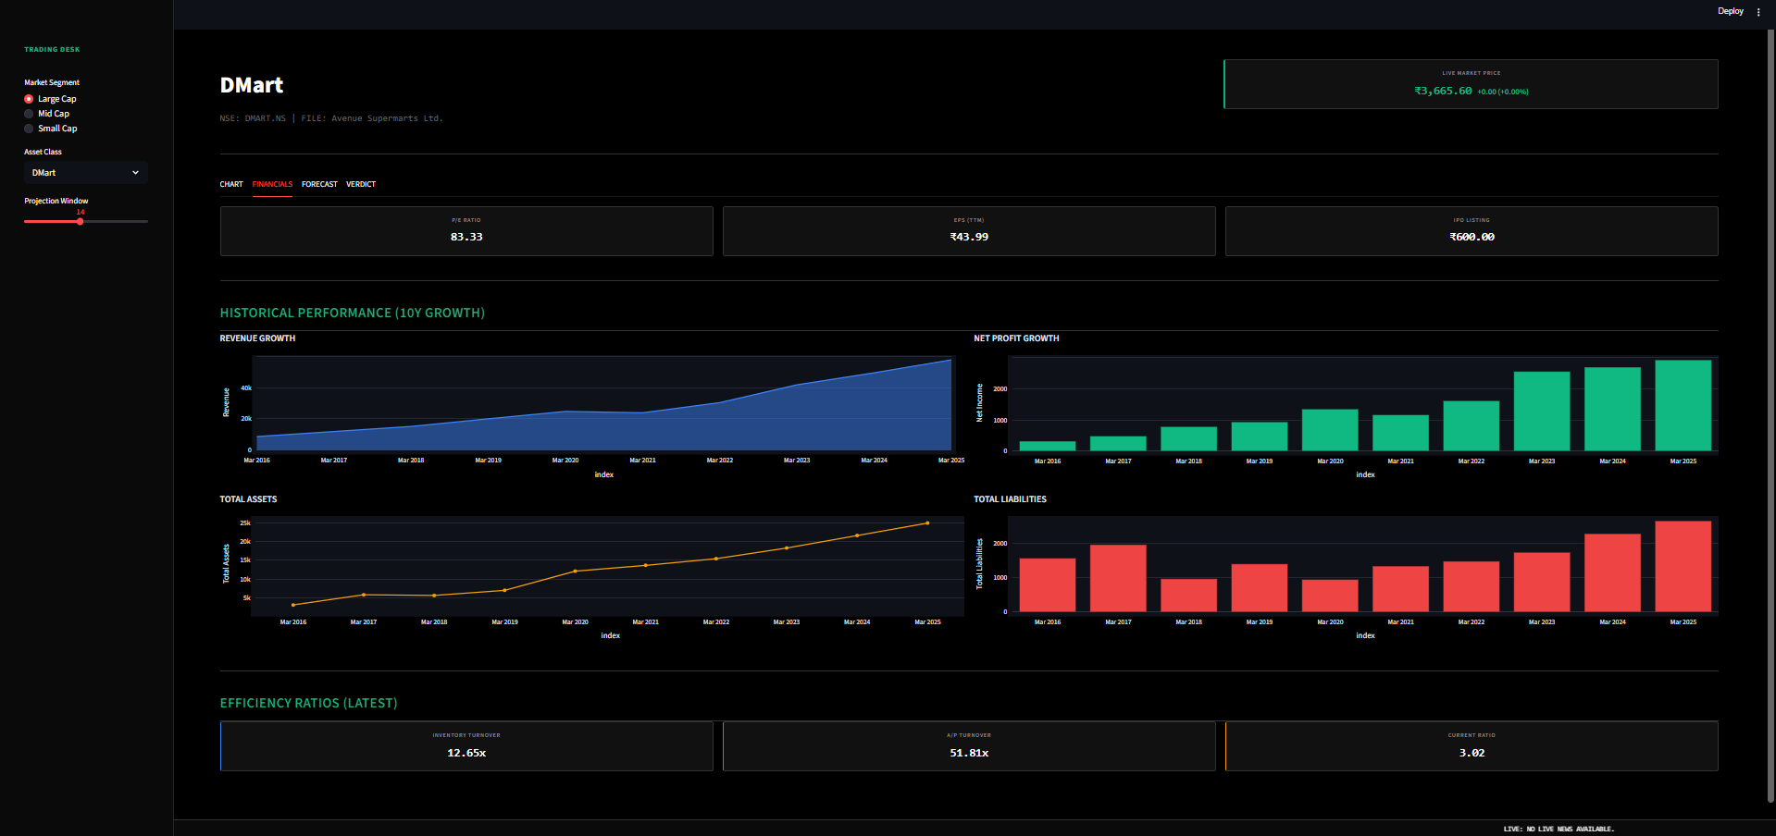
Figure 3.1: Trend Analysis and Comparison Based on Historical Data

3.2 Computational Layer (The "Brain")
The Python backend processes data through three distinct modules:
- Financials Module: Cleans raw CSV data, handles missing values, and computes ratios (e.g., Inventory Turnover = Cost of Goods Sold / Average Inventory.)
- Prediction Engine (Ensemble):
  - Feature Engineering: Creates inputs like Moving Averages (5-day, 20-day), RSI, Bollinger Bands, and Lagged Prices.
  - Model Selection: The system dynamically trains three models—Random Forest, Gradient Boosting, and Ridge Regression—on 90% of the data. It then evaluates them using the $R^2$ metric on the validation set and automatically selects the highest-performing model for the final forecast.
- Verdict Logic: A rule-based algorithm that assigns a composite score based on technical trends (Moving Averages) and fundamental health (P/E Ratio).

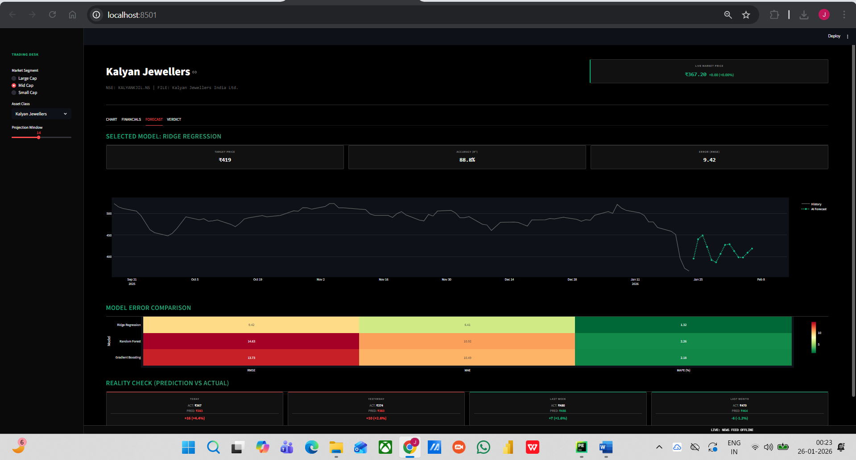
Figure 3.2: Prediction Model Forecasting

3.3 Visualization Layer
The frontend is built using Streamlit, offering an interactive web dashboard. Plotly is used for interactive charting (Candlestick charts for stock prices, Stacked Bar charts for Balance Sheets).

Chapter 4: Implementation& Analysis

4.1 Fundamental Analysis
The system performs a Trend Analysis, converting absolute figures into growth percentages. This highlights structural changes, such as a company shifting from debt-heavy to equity-heavy financing.
- Key Insight: The dashboard flagged how certain Mid-Cap companies maintained profitability despite revenue stagnation by improving operational efficiency (higher Inventory Turnover).
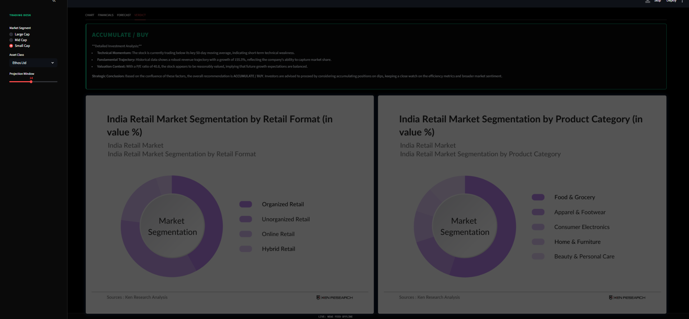
Figure 4: Analysis Verdict

Chapter 5: Results and Discussion

The developed dashboard successfully integrates diverse data streams into a unified view.
5.1 Dashboard Output The interface allows users to toggle between market segments (Large/Mid/Small Cap).
- Trend Analysis: Visualizes the 10-year growth of Revenue vs. Net Profit.
- Forecast Tab: Displays a projected price line alongside a "Reality Check" metric. This feature validates the model by comparing its past predictions (for Yesterday, Last Week) against actual closing prices, fostering user trust.
- Verdict Section: Provides a generated "Analyst Note" summarizing the Technical, Fundamental, and Valuation context into a coherent recommendation.
5.2 Interpretation The analysis reveals that companies with robust Net Profit Growth (fundamental) and Prices above the 50-Day Moving Average (technical) consistently received "ACCUMULATE" or "BUY" ratings, aligning with standard investment theory.

Chapter 6: Conclusion & Future Scope

6.1 Conclusion
The Financial Analytics Dashboard effectively translates complex raw data into actionable investment intelligence. By automating ratio calculations and employing a competitive multi-model prediction engine, the system reduces stock screening time from hours to seconds. It provides a scientifically backed basis for financial decision-making.
6.2 Limitations
- Macro Factors: The model currently does not account for external economic shocks (e.g., inflation rates, GST changes).
- Sentiment Analysis: It relies purely on quantitative data, ignoring news sentiment or brand perception.
6.3 Future Scope
Future iterations could incorporate Natural Language Processing (NLP) to analyze annual report texts and news articles for sentiment scoring. Additionally, integrating macroeconomic indicators (GDP growth) into the predictive models could improve long-term accuracy.

REFERENCES
- Breiman, L. (2001). "Random Forests". Machine Learning, 45(1), 5-32.
- CMIE Prowess Database. (2025). Audited Financial Statements of Indian Retail Companies.
- Friedman, J. H. (2001). "Greedy Function Approximation: A Gradient Boosting Machine". Annals of Statistics, 29(5), 1189-1232.
- Wilder, J. W. (1978). New Concepts in Technical Trading Systems. Trend Research
- Yahoo Finance API Documentation. (2025). Real-time Market Data Endpoints,

